CSE 595 Independent Study

Graph Theory

Week 2

California State University - San Bernardino

Richard Vargas

Supervisor – Dr Owen Murphy

Problem 19 (Bipartite Graphs)



In a bipartite graph, all nodes in *U* must be connected to nodes in *W*. Therefore, there must be 60 edges from *U* to *W*, by the fact that *U* has 10 nodes each with 6 degrees. Counting the amount of edges given in *W*, it is known that there are $\left(4×2\right)+\left(3×4\right)=20$ edges from the four vertices of degree 2, and three vertices of degree 4. The remaining number of vertices is determined by their degree, which is 8. Since $60-20=40$ edges remain, $\frac{40}{8}=5$ nodes of degree 8 must exists in *W*.

By definition of a bipartite graph, all nodes of *G* are separated into the sets *U* and *W*. Therefore, we can say

$$n=|W|+|U|$$

$$n=12+10$$

$$∴n=22∎$$

Problem 23 (Operations on Graphs)



Any graph with a partite set with 3 or more nodes will have a complement with a triangle, and thus in a bipartite setting, both partite sets may not have more than 3 nodes. Therefore, size of *G* will be 4 or less.

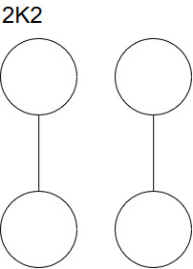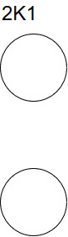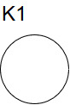The solution are then the following graphs,

$$K_{1},K_{2}, 2K_{1},2K_{2}∎$$

$K_{1}$ and 2 $K_{2}$ are self-complementary because they are isomorphic to its complement.

$K_{2}$ has a compliment of ${2K}_{1}$

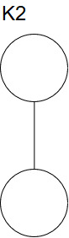

Problem 25 (Operations on Graphs)



By Theorem 1.7 in Chartrand [1],

For integers *r* and *n*, there exists an *r­*-regular graph of order *n* if and only if $0≤r≤n-1$ and *r* and *n* are not both odd.

Therefore, we know that solutions exist for both problems.

1. It is easier to look at the compliment of graph $G$ which will be denoted by $\overline{G}$. Thus, by

definition [1] the order and size of $\overline{G}$ is determined by $G$. Since $G$ is of order 7 and each vertex has degree of 6, then size m of $G$ is $\frac{\left(7\right)\left(4\right)}{2}=14$, then $\overline{G}$ is of order 7 and size $\left({7 \atop 2}\right)-14=7$. We can conclude from the order and size that $\overline{G}$ must be a cycle. The only two graphs that may exist are $C_{7}$ and $C_{4}+C_{3}$ because of the fact cycles must have order $≥3.∎$

1. Once again, it is better to look at the compliment of *G*. The order of *G* is 9 and each vertex has degree 6, then size m of *G* is = $\frac{(9)(6)}{2}=27$, then $\overline{G}$ is of order 9 and size $\left({9 \atop 2}\right)-27=9$. $\overline{G}$ must be constructed from cycles, so the possible cycles are $C_{9},C_{6}+C_{3},C_{5}+C_{4},$ and ${3C}_{3}$. $∎$

Problem 35 (Degree Sequences)



We may begin by labeling the nodes in *G* in order to transform using 2-switches to transform into *H*.

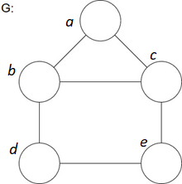Thus, we may delete *bc* and *de* from *G* , and add *cd* and *be* In order to create the graph *H.*

$$G-bc-de+cd+be∎$$

Problem 37 (Degree Sequences)



1. Is not graphical. If graph *G* has 5 vertices, two of which are degree 4, then the other vertices must have degree $≥2$.
2. Is graphical and can be constructed using bipartite graphs of .
3. A close up of a logo

   Description automatically generatedIs graphical and is constructed below.
4. Is not graphical. Using Theorem 1.12 (Havel-Hakimi Theorem) [1] we may apply the algorithm until either a sequence of 0’s is reached, which implies the sequence is graphical, or until a negative number is reached, which implies a nongraphical sequence.

$$s:7,6,6,5,4,3,2,1$$

$$s_{1}^{'}:5,5,4,3,2,1,0$$

$$s_{2}^{'}:4,3,2,1,0,0$$

$$s_{3}^{'}:2,1,0,-1,0$$

A negative number is reached, and therefore the sequence is nongraphical.

1. A picture containing sky

   Description automatically generatedIs graphical and is constructed below.

Works cited

“Introduction.” *Graphs & Digraphs*, by Gary Chartrand et al., CRC Press, 2016, pp. 13–24.